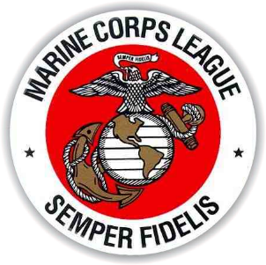
George LaMont
COMMANDANT – DEPARTMENT OF FLORIDA
MARINE CORPS LEAGUE
3048 Longford Lane
Brooksville, Florida 34601
Phone: 850.508.3611
Email: MarineLaMont@yahoo.com

NOVEMBER 2018 MONTHLY MESSAGE

Happy Birthday Marines!!!

Here it is November again and probably the busiest month for most of us Marine Corps Leaguers. There will be Birthday Balls, cake cutting ceremonies, Veterans Day parades and remembrances, Toys For Tots ramping up to full speed, and Thanksgiving Day with families and friends. With all the activities this month we must still focus on our missions. Do not forget all of those currently serving, and those that have suffered in the weather events this year.

Many of our members are dealing with recovery following Hurricane Michael’s devastation in the Central Panhandle of Florida, the home of two of our Detachments and about 140 of our members. Donations continue to arrive from across the Marine Corps League but so much more will be needed if we are to help our fellow members. Although a date has yet to be determined SVC Glassford and I plan to visit the area, check on our members, and provide whatever assistance we can. If there is an opportunity for your Detachment, Pound, or MCLA unit to donate to the Department’s Disaster relief fund please do. Donations may be sent to Paymaster Janis Beal.

Each Detachment must implement a plan and procedure to properly review the DD-214 of every new veteran member. Identify members with some knowledge of the DD-214 and task them with thoroughly reviewing every DD-214. Evaluate all the information contained on the document. Do not be in a rush to swear in the new member. The Department is working to identify ways to support the Detachments in the review of a submitted DD-214.

Thank you for everything you do in your communities, for veterans, and for your fellow Department of Florida and Detachment members.

Semper Fidelis,
George

